Appendix 2: Recommended Devices compatible with DETNSW network
All devices below come with the Windows 10 Operating System and are compatible with NSW Department of Education wireless network standards.
HP Pavilion 13-an1049tu  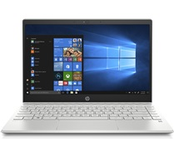 | Features  10th Gen Intel® Core™ i5 processor 1.0 GHz base  8 GB RAM DDR4-2400  256GB SSD M.2 2280 PCIe NVMe Opal2  13.3” Full High Definition Display  Webcam  Wi-Fi 802.11ac  Bluetooth 5  No stylus  Weight 1.3 kilograms  3-year onsite warranty  Price approximately $1099.00
Lenovo ThinkPad L13 Yoga  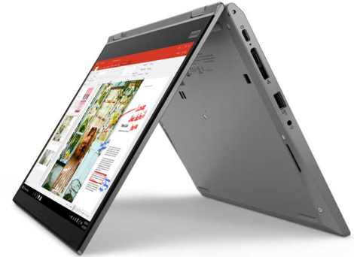 | Features  10th Gen Intel® Core™ i5/i7 processor  2-in-1 flexible laptop  8GB RAM Soldered DDR4-2666  256GB SSD M.2 2280 PCIe NVMe Opal2  13.3” Full High Definition Display  WebCam  ThinkPad Pen Pro stylus (garaged)  No optical drive  Wi-Fi 802.11ac/ax  Bluetooth 5  Weight 1.43 kilograms  3-year onsite warranty  Price approximately $1559.00
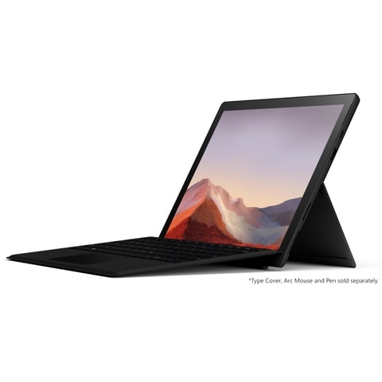  Microsoft Surface Pro 7 | Features  10th Gen Intel® Core™ i5/i7 processor  8GB RAM  256GB SSD M.2 2280 PCIe NVMe  13.3” Full High Definition Display  Webcam  Wi-Fi 802.11ac/ax  Bluetooth Wireless 5.0 technology  Weight 0.8 kilograms  3-year onsite warranty  Price approximately $1799.00
isted below are the computer specifications required if the recommended devices are not purchased.

Appendix 3: Specifications required for bring your own devices
Wireless connectivity:
802.11ac

Operating system:
Windows 10 or Mac OSX 10.15

Software and apps:
Microsoft Office 365 and Adobe Suite under the DETNSW licence

Battery life:
8-10 hours

Storage and RAM:
256 GB Solid State Disk and 8GB RAM

Hardware features:
Optional Wireless Mouse as needed

Accessories and other considerations:
Wireless mouse if necessary

